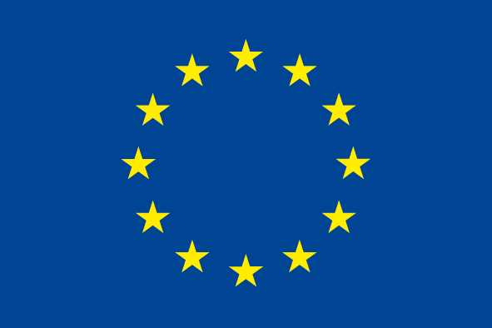
EUROPEAN REGIONAL
DEVELOPMENT FUND

INTERREG IVC Information Point South

REGISTRATION FORM

Lead Applicant Workshop and/or Individual Project Consultations
8 & 9 February 2011, Hotel Altis, Lisbon, Portugal

A: Registration details

Applicants registering for INTERREG IVC Lead Applicant Workshop and/or Individual Consultations need to complete this form. Thank you for being as precise, clear and understandable as possible. We can only confirm participation at the seminar and consultations if the information form is completely filled in.

Please note that the Lead Applicant Workshop on 8 February 2011 and individual consultations on 9 February 2011 are mainly targeted towards Lead Applicants from South Programme areas: Cyprus, Italy, Greece, Malta, Portugal and Spain.

1 Select the event

Lead Applicant Workshop 8 February 2011

Individual Project Consultation 9 February 2011 (the exact 45-minute time slot will be communicated in the confirmation e-mail)
2 Contact details

First / last name:
Organisation:
Type of organisation: | Managing Authority (MA)
Type of organisation: | Intermediate Body (carrying out some or all tasks of the MA)
Type of organisation: | Other - please specify:
Address:
Postcode / Town:
Country:
Email: |  | Tel:
Mobile phone: |  | Fax:
Dietary requirements | Vegetarian: Yes No  Special dietary requirements:

Please note that you will receive a confirmation of your request by e-mail.
Please do not make any travel arrangements until you have received this confirmation.
3 Accompanying persons
Please provide the contacts of the people accompanying you to this consultation (if applicable):

1.
First / last name:
Organisation:
Address:
Postcode / Town:
Country:
E-mail: |  | Tel:
Mobile phone: |  | Fax:
Dietary requirements | Vegetarian: Yes No  Special dietary requirements:

2.
First / last name:
Organisation:
Address:
Postcode / Town:
Country:
E-mail: |  | Tel:
Mobile phone: |  | Fax:
Dietary requirements | Vegetarian: Yes No  Special dietary requirements:

3.
First / last name:
Organisation:
Address:
Postcode / Town:
Country:
E-mail: |  | Tel:
Mobile phone: |  | Fax:
Dietary requirements | Vegetarian: Yes No  Special dietary requirements:
B: Description of project idea

Project acronym: |  |  | Lead Partner:
Please select one sub-theme you intend to apply for (cf. section 1.4 of the programme manual):
Priority 1 | Innovation, research and technology development
Priority 1 | Entrepreneurship and SMEs
Priority 1 | Information society
Priority 1 | Employment, human capital and education
Priority 2 | Natural and technological risks (incl. climate change)
Priority 2 | Water management
Priority 2 | Waste prevention and management
Priority 2 | Biodiversity and preservation of natural heritage (incl. air quality)
Priority 2 | Energy and sustainable transport
Priority 2 | Cultural heritage and landscape

Please describe the regional development issue addressed by your project. What is the field tackled? What regional development policies are concerned? Examples of good practices to be transferred can also be provided. (2,000 characters maximum):
Cf. section 1.4 of the programme manual

Please describe the main objectives of the project. Which regional Operational Programmes (or specific measures) will be targeted? (1,500 characters maximum):
Cf. section 2.1.2 of the programme manual

Please describe the partnership envisaged (i.e. nature and location)? How are managing authorities (or intermediate bodies) involved? What is the role of other institutions? (2,000 characters maximum):
Cf. section 2.1.2 of the programme manual

Please describe the main activities envisaged in the project (3,500 characters maximum):
Cf. sections 2.1 and 2.2 of the programme manual

If you would like to ask further questions, please list them below:

Please return the form to: IP-South@interreg4c.eu

